UNIT V
INTERFACING MICROCONTROLLER
Programming 8051 Timers - Serial Port Programming - Interrupts Programming – LCD & Keyboard Interfacing - ADC, DAC & Sensor Interfacing - External Memory Interface- Stepper Motor and Waveform generation.

5.1: PROGRAMMING TIMERS OF 8051
- Explain the different modes of operation of timers in 8051 in detail with its associated registers.
Describe different modes of operation of timers /counters in 8051 with its associated registers. (NOV 2009, MAY 2009. May 2007, May 2016)
Draw and explain the functions of TCON and TMOD registers of 8051. (Dec 2008)
Explain the on-chip timer modes of an 8051 Microcontroller. (April 2010, NOV 2016)
Timer Registers.
- The 8051 has two timers/counters, they can be used either as timers (used to generate a time delay)
or as event counters.
TIMER 0:
- Timer 0 is a 16-bit register and can be treated as two 8-bit registers (TL0 & TH0).
- These registers can be accessed similar to any other registers like A, B or R1 etc
- Ex : The instruction MOV TL0,#07 moves the value 07 into lower byte of Timer0.
- Similarly MOV R1, TH0 saves the contents of TH0 in the R1 register.
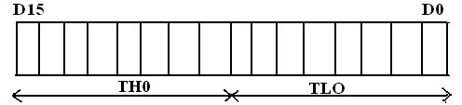
TIMER 1:
- Timer 1 is also a 16-bit register and can be treated as two 8-bit registers (TL1 & TH1).
- These registers can be accessed similar to any other registers like A, B or R1etc
- Ex : The instruction MOV TL1,#05 moves the value 05 into lower byte of Timer1.
- Similarly MOV R0,TH1 saves the contents of TH1 in the R0 register.

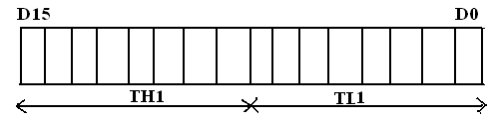
TMOD (Timer mode Register):
- The various operating modes of both the timers T0 and T1 are set by a TMOD register.
- TMOD is a 8-bit register.
- The lower 4 bits are for Timer 0
- The upper 4 bits are for Timer 1
- In each case,
- The lower 2 bits are used to set the timer mode
- The upper 2 bits to specify the operation
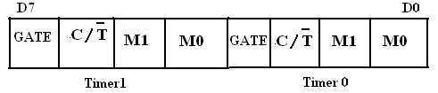
GATE:
- This bit is used to start or stop the timers by hardware.
- When GATE= 1, the timers can be started / stopped by the external sources.
- When GATE= 0, the timers can be started or stopped by software instructions like SETB TR_{X}
or CLR TR_{X.}
C/T (Counter/Timer):
- This bit decides whether the timer is used as delay generator or event counter.
- When = 0, timer is used as delay generator.
- When =1, timer is used as an event counter.
- The clock source for the time delay is the crystal frequency of 8051.
- The clock source for the event counter is the external clock source.
M1, M0 (Mode):
- These two bits are the timer mode bits.
- The timers of the 8051 can be configured in four modes Mode0, Mode1, Mode2 & Mode 3.
- The selection and operation of the modes is shown below.

S.No | M0 | M1 | Mode | Operation
1 | 0 | 0 | Mode 0 | 13-bit Timer mode.  8-bit Timer/counter THx with TLx as 5-bit prescaler
2 | 0 | 1 | Mode 1 | 16-bit Timer mode.16-bit timer /counter THx and TLx are cascaded. There is no presacler
3 | 1 | 0 | Mode 2 | 8-bit auto reload.  8-bit auto reload timer/counter. THx holds a value which is to be reloaded TLx each time it overflows
4 | 1 | 1 | Mode 3 | Split timer mode

Mode 0: 13 bit Timer mode
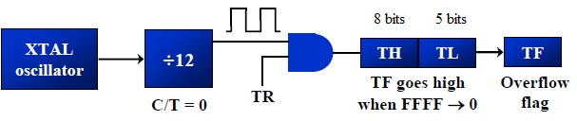

Mode 1: 16 bit Timer mode
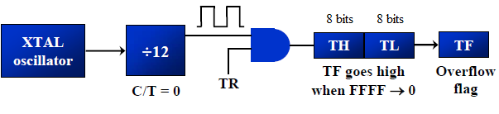

Mode 2: 8 bit auto reload mode
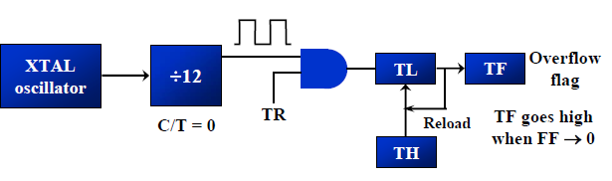

Mode 3: Split Timer mode
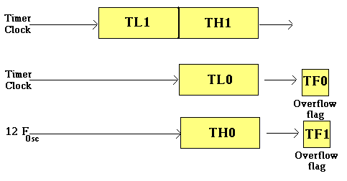
Figure: Modes of operation of Timer
TCON (Timer control register)
- TCON (timer control) register is an 8-bit register. TCON register is a bit-addressable register.
Bit  Number | Bit  Mnemonic | Description
7 | TF1 | Timer 1 overflow flag  Cleared by hardware when processor vectors to interrupt routine.  Set by hardware on timer/counter overflow, when the timer 1 register overflows.
6 | TR1 | Timer 1 run control bit  Clear to turn off time/counter 1.  Set to turn on timer/counter 1.
5 | TF0 | Timer 0 overflow flag  Cleared by hardware when processor vectors to interrupt routine.  Set by hardware on timer/counter overflow, when the timer 0 register overflows.
4 | TR0 | Timer 0 run control bit  Clear to turn off time/counter 0.  Set to turn on timer/counter 0.
3 | IE1 | External interrupt 1 edge flag.  Cleared by hardware when interrupt is processed if edge-triggered.  Set by hardware when external interrupt is detected on INT1 pin.
2 | IT1 | External interrupt 1 type control bit  Clear to select low level active (level triggered) for external interrupt 1.  Set to select falling edge active (edge triggered) for external interrupt 1.
1 | IE0 | External interrupt 0 edge flag  Cleared by hardware when interrupt is processed if edge-triggered.  Set by hardware when external interrupt is detected on INT0 pin.
0 | IT0 | External interrupt 0 type control bit  Clear to select low level active (level triggered) for external interrupt 0.  Set to select falling edge active (edge triggered) for external interrupt 0.

Timers of 8051 do starting and stopping by either software or hardware control
- For using software to start and stop the timer where GATE=0
- The start and stop of the timer are controlled by software using TR (timer start) bits TR_{X} and CLR_{X}
- The SETB instruction starts it, and it is stopped by the CLR instruction.
- These instructions start and stop the timers as long as GATE=0 in the TMOD register
- The hardware way of starting and stopping the timer is achieved by making GATE=1 in the
TMOD register.
The following are the characteristics and operations of mode 1:
1. It is a 16-bit timer.
2. It allows value from 0000 to FFFFH.
3. Value to be loaded into the timer register TL and TH.
4. After TH and TL are loaded with a 16-bit initial value, the timer must be started
- This is done by SETB TR0 for timer 0 and SETB TR1 for timer 1
5. After the timer is started, it starts to count up
  - It counts up until it reaches its limit of FFFFH
  - When it rolls over from FFFFH to 0000, it sets high a flag bit called TF (timer flag)
  - Each timer has its own timer flag.
  - There are TF0 for timer 0, and TF1 for timer 1.

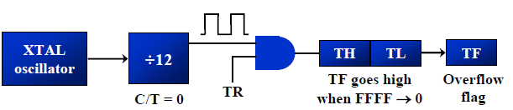
6. Timer flag can be monitored,
  - When this timer flag is raised, to stop the timer with the CLR instructions.
  - CLR TR0 and CLR TR1, for timer 0 and timer 1 respectively.
  - After the timer reaches its limit and rolls over.
  - In order to repeat the process, TH and TL must be reloaded with the original value and TF must be reloaded to 0.

To generate a time delay
1. Load the TMOD register indicating which timer is to be used and which timer mode is selected.
2. Load registers TL and TH with initial count value.
3. Start the timer
4. Keep monitoring the timer flag (TF) with the JNB TFx , target to see if it is raised
- Get out of the loop when TF becomes high
5. Stop the timer
6. Clear the TF flag for the next round
7. Go back to Step 2 to load TH and TL again.
Example 1:
In the following program, we create a square wave of 50% duty cycle (with equal portions high and low) on the P1.5 bit. Timer 0 is used to generate the time delay. Analyze the program. (Nov 2014)
MOV TMOD,#01 ;Timer 0, mode 1(16-bit mode)
HERE: MOV TL0,#0F2H ;TL0=F2H, the low byte
MOV TH0,#0FFH ;TH0=FFH, the high byte
CPL P1.5 ;toggle P1.5
ACALL DELAY
SJMP HERE
DELAY: SETB TR0 ;start the timer 0
AGAIN: JNB TF0,AGAIN ;monitor timer flag 0 until it rolls over
CLR TR0 ;stop timer 0
CLR TF0 ;clear timer 0 flag
RET
In the above program notice the following steps.
1. TMOD is loaded.
2. FFF2H is loaded into TH0-TL0.
3. P1.5 is toggled for the high and low portions of the pulse.
4. The DELAY subroutine using the timer is called.
5. In the DELAY subroutine, timer 0 is started by the SETB TR0 instruction.
6. Timer 0 counts up with the passing of each clock, which is provided by the crystal oscillator.
- As the timer counts up, it goes through the states of FFF3, FFF4, FFF5, FFF6, and so on until it reaches FFFFH.
- One more clock rolls it to 0, raising the timer flag (TF0=1). At that point, the JNB instruction falls through.
7. Timer 0 is stopped by the instruction CLR TR0.
- The DELAY subroutine ends and the process is repeated.

Notice that to repeat the process, we must reload the TL and TH registers, and start the process is repeated.
Example 2:
In Example 1, calculate the amount of time delay in the DELAY subroutine generated by the timer. Assume XTAL = 11.0592 MHz.
Solution:
- The timer works with a clock frequency of 1/12 of the XTAL frequency, we have 11.0592 MHz / 12 = 921.6 kHz as the timer frequency.
- As a result, each clock has a period of T =1/921.6kHz,T=1.085µs.
- In other words, Timer 0 counts up each 1.085µs resulting in delay = number of counts × 1.085µs.
- The number of counts for the roll over is FFFFH – FFF2H = 0DH (13 decimal).
- Add one to 13 because of the extra clock needed when it rolls over from FFFF to 0 and raise the TF flag.
- This gives 14 × 1.085µs = 15.19µs for half the pulse. For the entire period it is T = 2 × 15.19µs = 30.38µs as the time delay generated by the timer.
(a) In hexadecimal
(FFFF – YYXX + 1) ×1.085 µs, where YYXX are TH, TL initial values respectively. Notice that value YYXX are in hex.
(b) In decimal
Convert YYXX values of the TH, TL register to decimal to get a NNNN decimal, then (65536 - NNNN) ×
1.085 µs

Example 3:
In Example 1, calculate the frequency of the square wave generated on pin P1.5.
Solution:
- In the timer delay calculation of Example 1, we did not include the overhead due to instruction in the loop.
- To get a more accurate timing, we need to add clock cycles due to these instructions in the loop.
- To do that, we use the machine cycle as shown below.

Cycles
HERE: MOV TL0,#0F2H 2
MOV TH0,#0FFH 2
CPL P1.5 1
ACALL DELAY 2
SJMP HERE 2
DELAY: SETB TR0 1
AGAIN: JNB TF0, AGAIN 14
CLR TR0 1
CLR TF0 1
RET 2
Total 28
T = 2 × 28 × 1.085 us = 60.76 µs and F = 16458.2 Hz
Example 4:
Find the delay generated by timer 0 in the following code, using both of the Methods. Do not include the overhead due to instruction.
CLR P2.3 ;Clear P2.3
MOV TMOD,#01 ;Timer 0, 16-bitmode
HERE: MOV TL0,#3EH ;TL0=3Eh, the low byte
MOV TH0,#0B8H ;TH0=B8H, the high byte
SETB P2.3 ;SET high timer 0
SETB TR0 ;Start the timer 0
AGAIN: JNB TF0,AGAIN ;Monitor timer flag 0
CLR TR0 ;Stop the timer 0
CLR TF0 ;Clear TF0 for next round
CLR P2.3
Solution:
(FFFFH – B83E + 1) = 47C2H = 18370 in decimal and 18370 × 1.085 µs = 19.93145 ms

The following are the characteristics and operations of mode 2:
1. It is an 8-bit timer. It allows only values of 00 to FFH to be loaded into the timer register TH.
2. After TH is loaded with the 8-bit value, the 8051 copies value to TL register.
- Then the timer must be started.
- This is done by the instruction SETB TR0 for timer 0 and SETB TR1 for timer 1.
3. After the timer is started, it starts to count up by incrementing the TL register.
- It counts up until it reaches its limit of FFH
- When it rolls over from FFH to 00, it sets high the TF (timer flag)
- When the TL register rolls from FFH to 00 and TF is set to 1.

- TL is reloaded automatically with the original value kept by the TH register.
- To repeat the process, simply clear TF.
4. This makes mode 2 an auto-reload, in contrast with mode 1 in which the programmer has to reload
TH and TL
To generate a time delay
1. Load the TMOD value register indicating which timer is to be used, and the timer mode (mode 2) is selected.
2. Load the TH register with the initial count value.
3. Start timer.
4. Keep monitoring the timer flag (TF) with the JNB TFx, target, to see whether it is raised
Get out of the loop when TF goes high
5. Clear the TF flag.
6. Go back to Step4, since mode 2 is auto reload.

Example 5:
Assume XTAL = 11.0592 MHz, find the frequency of the square wave generated on pin P1.0.

MOV TMOD,#20H ;T1/8-bit/auto reload
MOV TH1,#5 ;TH1 = 5
SETB TR1 ;start the timer 1
BACK: JNB TF1,BACK ;till timer rolls over
CPL P1.0 ;P1.0 to hi, lo
CLR TF1 ;clear Timer 1 flag
SJMP BACK ;mode 2 is auto-reload
Solution:
- In mode 2, no need to reload TH since it is auto-reload.
- Now (256 - 05) × 1.085 µs =251 × 1.085 µs = 272.33 µs is the high portion of the pulse.
- Since it is a 50% duty cycle square wave, the period T is twice.
- As a result T = 2 × 272.33 µs = 544.67 µs and the frequency = 1.83597 kHz

5.2: Timers as counters
Timers can also be used as counters.
Which are used for counting events happening outside the 8051.
- When it is used as a counter, it is a pulse outside of the 8051 that increments the TH, TL register.
- TMOD and TH, TL registers are the same as in timer concept, except the source of the frequency.
- The C/T bit in the TMOD register decides the source of the clock for the timer
- When C/T = 1, the timer is used as a counter and gets its pulses from outside the 8051.
- The counter counts up as pulses are fed from pins 14 and 15.
- these pins are called T0 (timer 0 input) and T1 (timer 1 input)
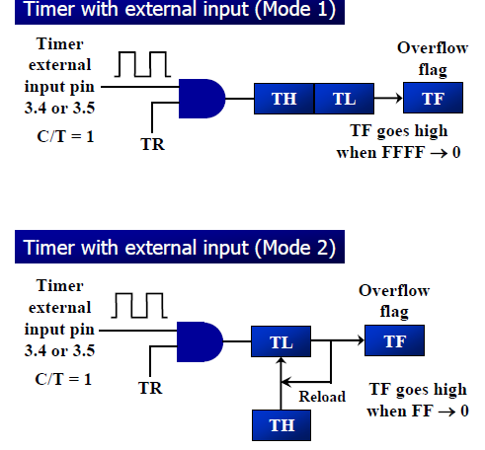
- If GATE = 1, the start and stop of the timer are done externally through pins P3.2 and P3.3 for timers 0 and 1, respectively
- This hardware allows starting or stopping the timer externally at any time via a simple switch

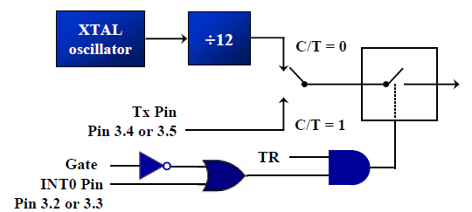
- The frequency for the timer is always 1/12th the frequency of the crystal attached to the 8051.

Example 6:
Assuming that clock pulses are fed into pin T1, write a program for counter 1 in mode 2 to count the pulses and display the state of the TL1 count on P2, which connects to 8 LEDs.
Solution:
MOV TM0D,#01100000B ;counter 1, mode 2, C/T=1 external pulses
MOV TH1,#0 ;clear TH1
SETB P3.5 ;make T1 input
AGAIN: SETB TR1 ;start the counter
BACK: MOV A,TL1 ;get copy of TL
MOV P2,A ;display it on port 2
JNB TF1,Back ;keep doing, if TF = 0
CLR TR1 ;stop the counter 1
CLR TF1 ;make TF=0
SJMP AGAIN ;keep doing it
- Notice in the above program the role of the instruction SETB P3.5.
- Since ports are set up for output when the 8051 is powered up.
- So, we make P3.5 an input port by making it high.
- In other words, we must configure (set high) the T1 pin (pin P3.5) to allow pulses to be fed into it.

5.3: SERIAL COMMUNICATION

2. Explain the serial programming of 8051 with its associated registers. (May 2014, 2013)(Or)
Explain how to program for sending and receiving data serially using 8051 (April 2010, 2011)
Explain 8051 serial port programming with examples. (May 2016, NOV 2012)
Explain the serial modes of operation of 8051 microcontroller. (May 2007)

RS232
- It is an interfacing standard RS232.
- It was set by the Electronics Industries Association (EIA) in 1960.
- The standard was set long before the advent of the TTL logic family.
- Its input and output voltage levels are not TTL compatible.
- In RS232, a 0 is represented by -3 to -25 V, while a 1 bit is +3 to +25 V.
- IBM introduced the DB-9 version of the serial I/O standard.
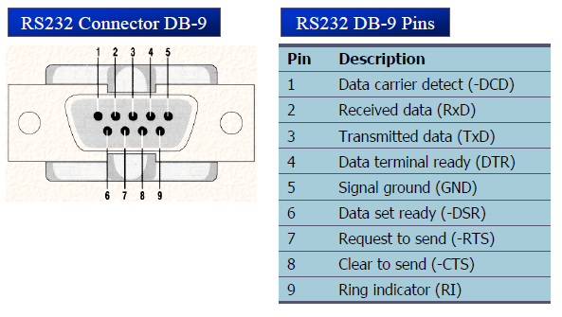
Handshake signals of MODEM
DTR (data terminal ready)
- When DTR =1, indicate that it is ready for communication.
DSR (data set ready)
- When DSR =1, indicate that it is ready for communication.
RTS (request to send)
- It asserts RTS to signal the modem that it has a byte of data to transmit.
CTS (clear to send)
- It is to receive, it sends out signal CTS,

DCD (data carrier detect)
- The modem asserts signal DCD to inform the DTE that a valid carrier has been detected.
RI (ring indicator)
- An output from the modem and an input to a PC indicates that the telephone is ringing.

MAX232
A line driver ( MAX232) is required to convert RS232 voltage levels to TTL levels, and vice versa.
- 8051 has two pins that are used specifically for transferring and receiving data serially.
- These two pins are called TxD and RxD and are part of the port 3 (P3.0 and P3.1).
- These pins are TTL compatible.
- They require a line driver to make them RS232 compatible.
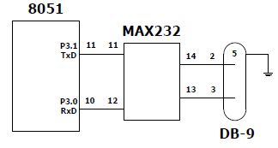
Baud rate:
- The baud rates in 8051 are programmable.
- 8051 divides the crystal frequency by 12 to get machine cycle frequency.
- 8051 UART circuitry divides the machine cycle frequency by 32.
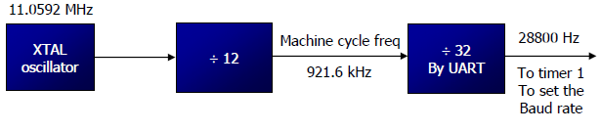
- Timer 1 is used to set baud rate using TH1 register
Baud rate | TH1 (decimal) | TH1(Hex)
9600 | -3 | FD
4800 | -6 | FA
2400 | -12 | F4
1200 | -24 | E8

Explain in detail the serial communication registers of the 8051. (NOV 2009)
SBUF:
- It is an 8-bit register used for serial communication.
- For a byte data to be transferred via the TxD line:
- Byte must be placed in the SBUF register.
- Bytes are framed with the start and stop bits and transferred serially via the TxD line.
- SBUF holds the byte of data when it is received by 8051 RxD line.
- When the bits are received serially via RxD.
- 8051 de-frames byte by eliminating the stop and start bits.

SCON:
- It is an 8-bit register used to program the start bit, stop bit and data bits of data framing.
SM0 | SM1 | SM2 | REN | TB8 | RB8 | TI | RI

Bit  Number | Bit  Mnemonic | Description
SCON.7 | SM0 | Serial port mode specifier
SCON.6 | SM1 | Serial port mode specifier
SCON.5 | SM2 | Used for multiprocessor communication
SCON.4 | REN | Set/Cleared by software to enable/disable reception
SCON.3 | TB8 | Not widely used
SCON.2 | RB8 | Not widely used
SCON.1 | TI | Transmit interrupt flag. Set by hardware at the begin of the stop bit mode 1.  And cleared by software
SCON.0 | RI | Receive interrupt flag. Set by hardware at the begin of the stop bit mode 1.  And cleared by software

SM0, SM1: Serial port mode specifiers
SM0 SM1
0 0 Serial Mode 0
0 1 Serial Mode 1; 8-bit data, 1 stop bit, 1 start bit
1 0 Serial Mode 2
1 1 Serial Mode 3

In programming the 8051 to transfer character bytes serially

1. TMOD register is loaded with the value 20H, indicating the use of timer 1 in mode 2 (8-bit auto-
reload) to set baud rate.
2. The TH1 is loaded with one of the values to set baud rate for serial data transfer.
3. The SCON register is loaded with the value 50H, indicating serial mode 1, where an 8-bit data is framed
with start and stop bits.
4. TR1 is set to 1 to start timer 1
5. TI is cleared by CLR TI instruction.
6. The character byte to be transferred serially is written into SBUF register.
7. The TI flag bit is monitored with the use of instruction JNB TI, xx, to see if the character has been
transferred completely.
8. To transfer the next byte, go to step 5.
Write a program for the 8051 to transfer letter “A” serially at 4800 baud, continuously.
Solution:
MOV TMOD, #20H ;timer 1, mode 2 (auto reload)
MOV TH1, #-6 ;4800 baud rate
MOV SCON, #50H ;8-bit, 1 stop, REN enabled
SETB TR1 ;start timer 1
AGAIN: MOV SBUF, #”A” ;letter “A” to trtansfer
HERE: JNB TI, HERE ;wait for the last bit
CLR TI ;clear TI for next char
SJMP AGAIN ;keep sending A

The steps that 8051 goes through in transmitting a character via TxD
1. The byte character to be transmitted is written into the SBUF register
2. The start bit is transferred
3. The 8-bit character is transferred on bit at a time
4. The stop bit is transferred
- It is during the transfer of the stop bit that 8051 raises the TI flag, indicating that the last
character was transmitted
5. By monitoring the TI flag, we make sure that we are not overloading the SBUF

- If we write another byte into the SBUF before TI is raised, the un-transmitted portion of the
previous byte will be lost.
6. After SBUF is loaded with a new byte, the TI flag bit must be forced to 0 by CLR TI in order for this
new byte to be transferred

By checking the TI flag bit, we know whether or not the 8051 is ready to transfer another byte
- It must be noted that TI flag bit is raised by 8051 itself when it finishes data transfer
- It must be cleared by the programmer with instruction CLR TI
- If we write a byte into SBUF before the TI flag bit is raised, we risk the loss of a portion of the byte being transferred
- The TI bit can be checked by the instruction JNB TI,xx Using an interrupt.

Write a program for the 8051 to transfer “YES” serially at 9600 baud, 8-bit data, 1 stop bit do this continuously. (May 2006)

Solution:
MOV TMOD, #20H ;timer 1, mode 2 (auto reload)
MOV TH1, #-3 ;9600 baud rate
MOV SCON, #50H ;8-bit, 1 stop, REN enabled
SETB TR1 ;start timer 1
AGAIN: MOV A, # “Y” ;transfer “Y”
ACALL TRANS
MOV A, # “E” ;transfer “E”
ACALL TRANS
MOV A, # “S” ;transfer “S”
ACALL TRANS
SJMP AGAIN ;keep doing it
;serial data transfer subroutine
TRANS: MOV SBUF, A ;load SBUF
HERE: JNB TI, HERE ;wait for the last bit
CLR TI ;get ready for next byte
RET

In programming the 8051 to receive character bytes serially
1. TMOD register is loaded with the value 20H, indicating the use of timer 1 in mode
(8-bit auto-reload) to set baud rate
2. TH1 is loaded to set baud rate
3. The SCON register is loaded with the value 50H, indicating serial mode 1, where an 8-bit data is framed
with start and stop bits
4. TR1 is set to 1 to start timer 1
5. RI is cleared by CLR RI instruction
6. The RI flag bit is monitored with the use of instruction JNB RI, xx to see if an entire character has
been received yet
7. When RI is raised, SBUF has the byte, its contents are moved into a safe place.
8. To receive the next character, go to step 5.

Write a program for the 8051 to receive bytes of data serially and put them in P1, set the baud rate at 4800, 8-bit data and 1 stop bit. (NOV 2016)
Solution:
MOV TMOD, #20H ;timer 1, mode 2 (auto reload)
MOV TH1, #-6 ;4800 baud rate
MOV SCON, #50H ;8-bit, 1 stop, REN enabled
SETB TR1 ;start timer 1
HERE: JNB RI, HERE ;wait for char to come in
MOV A, SBUF ;saving incoming byte in A
MOV P1, A ;send to port 1
CLR RI ;get ready to receive next byte
SJMP HERE ;keep getting data

In receiving bit via its RxD pin, 8051 goes through the following steps.
1. It receives the start bit
- Indicating that the next bit is the first bit of the character byte it is about to receive
2. The 8-bit character is received one bit at time
3. The stop bit is received
- When receiving the stop bit 8051 makes RI = 1,indicating that an entire character byte has
been received.

5. After the SBUF contents are copied into a safe place.
- The RI flag bit must be forced to 0 by CLR RI in order to allow the next received character byte to be placed in SBUF.
- Failure to do this causes loss of the received character.

There are two ways to increase the baud rate of data transfer
- To use a higher frequency crystal
- To change a bit in the PCON register
PCON
- PCON register is an 8-bit register
- When 8051 is powered up, SMOD is zero.
- We can set it to high by software and thereby double the baud rate.
- GF1, GF0: General flag bits
- PD: Power down mode
- IDL: Ideal mode
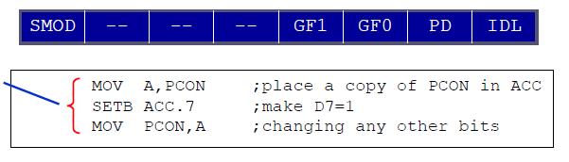
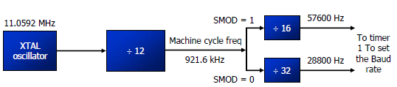
*******************************************************************

5.4: LCD Interfacing

3. Explain how LCD is used to interface with 8051. (May 2007)
How does one interface a 16 × 2 LCD Display using 8051 Microcontroller? (May2009, May 2010)

Introduction:
- Liquid Crystal displays are created by sandwiching a thin 10-12μm layer of a liquid-crystal
fluid between two glass plates.
- A transparent, electrically conductive film or backplane is put on the rear glass sheet.
- Transparent sections of conductive film in the shape of the desired characters are coated on the
front glass plate.
- When a voltage is applied between a segment and the backplane, an electric field is created
in the region under the segment.
- This electric field changes the transmission of light through the region under the segment film.
- Most LCD’s require a voltage of 2 or 3 V between the backplane and a segment to turn on
the segment.

There are two types available of LCD
- Dynamic scattering and field effect.
Dynamic scattering types of LCD:
- It scrambles the molecules where the field is present.
- This produces an etched-glass-looking light character on a dark background.
Field-effect types:
- Use polarization to absorb light where the electric field is present.
- This produces dark characters on a silver- gray background.
Advantages of LCD
  - LCD is finding widespread use replacing LEDs
  - The declining prices of LCD
  - The ability to display numbers, characters, and graphics
  - Ease of programming for characters and Graphics

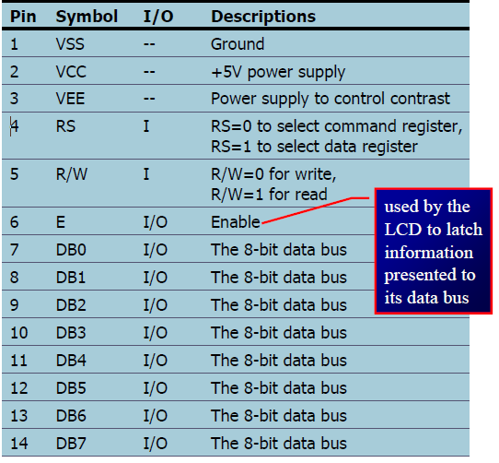
Fig:Pin details of LCD module
Interfacing LCD module
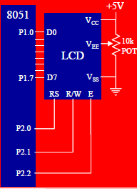
Fig: Interfacing LCD module with controller

LCD Command Codes
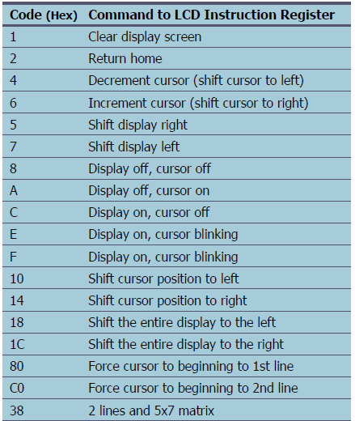
- To send any of the commands to the LCD, make pin RS=0. For data, make RS=1.
- Then send a high-to-low pulse to the E pin to enable the internal latch of the LCD.
- This is shown in the code below.
;calls a time delay before sending next data/command
;P1.0-P1.7 are connected to LCD data pins D0-D7
;P2.0 is connected to RS pin of LCD
;P2.1 is connected to R/W pin of LCD
;P2.2 is connected to E pin of LCD
ORG 0H
MOV A,#38H ;INIT. LCD 2 LINES, 5X7 MATRIX
ACALL COMNWRT ;call command subroutine
ACALL DELAY ;give LCD some time
MOV A,#0EH ;display on, cursor on
ACALL COMNWRT ;call command subroutine
ACALL DELAY ;give LCD some time
MOV A,#01 ;clear LCD

ACALL COMNWRT ;call command subroutine
ACALL DELAY ;give LCD some time
MOV A,#06H ;shift cursor right
ACALL COMNWRT ;call command subroutine
ACALL DELAY ;give LCD some time
MOV A,#84H ;cursor at line 1, pos. 4
ACALL COMNWRT ;call command subroutine
ACALL DELAY ;give LCD some time
MOV A,#’N’ ;display letter N
ACALL DATAWRT ;call display subroutine
ACALL DELAY ;give LCD some time
MOV A,#’O’ ;display letter O
ACALL DATAWRT ;call display subroutine
AGAIN: SJMP AGAIN ;stay here
COMNWRT: ;send command to LCD
MOV P1,A ;copy reg A to port 1
CLR P2.0 ;RS=0 for command
CLR P2.1 ;R/W=0 for write
SETB P2.2 ;E=1 for high pulse
ACALL DELAY ;give LCD some time
CLR P2.2 ;E=0 for H-to-L pulse
RET
DATAWRT: ;write data to LCD
MOV P1,A ;copy reg A to port 1
SETB P2.0 ;RS=1 for data
CLR P2.1 ;R/W=0 for write
SETB P2.2 ;E=1 for high pulse
ACALL DELAY ;give LCD some time
CLR P2.2 ;E=0 for H-to-L pulse
RET
DELAY: MOV R3,#50 ;50 or higher for fast CPUs
HERE2: MOV R4,#255 ;R4 = 255
HERE: DJNZ R4,HERE ;stay until R4 becomes 0
DJNZ R3,HERE2
RET
END

;Check busy flag before sending data, command to LCD
;p1=data pin
;P2.0 connected to RS pin
;P2.1 connected to R/W pin
;P2.2 connected to E pin

ORG 0H
MOV A,#38H ;init. LCD 2 lines ,5x7 matrix
ACALL COMMAND ;issue command
MOV A,#0EH ;LCD on, cursor on
ACALL COMMAND ;issue command
MOV A,#01H ;clear LCD command
ACALL COMMAND ;issue command
MOV A,#06H ;shift cursor right
ACALL COMMAND ;issue command
MOV A,#86H ;cursor: line 1, pos. 6
ACALL COMMAND ;command subroutine
MOV A,#’N’ ;display letter N
ACALL DATA_DISPLAY
MOV A,#’O’ ;display letter O
ACALL DATA_DISPLAY
HERE:SJMP HERE ;STAY HERE
*********************************************************************************
5.5: KEYBOARD INTERFACING
4. With neat circuit diagram explain how a 4 x 4 keypad is interfaced with 8051 microcontroller and write 8051 ALP for keypad scanning. (May 2013, Nov 2015, NOV 2007)
- Keyboards are organized in a matrix of rows and columns
- The CPU accesses both rows and columns through ports.
- Therefore, with two 8-bit ports, an 8 x 8 matrix of keys can be connected to a microprocessor.
- When a key is pressed, a row and a column make a contact.
- Otherwise, there is no connection between rows and columns.
- A 4x4 matrix is connected to two ports.
- The rows are connected to an output port and the columns are connected to an input port

Fig: Model of 4x4 matrix KEYBOARD

- It is the function of the microcontroller to scan the keyboard continuously to detect and identify the key pressed
To detect a pressed key:
- The microcontroller grounds all rows by providing 0, then it reads the columns
- Data read from columns is D3 – D0 = 1111. No key has been pressed and the process continues till key press is detected
- If one of the column bits has a zero, a key press has occurred.
- For example, if D3 – D0 = 1101, a key in the D1 column has been pressed.
- After detecting a key press, microcontroller will go through the process of identifying the key.
- Starting with the top row, the microcontroller grounds it by providing a low to row D0 only
- It reads the columns, if the data read is all 1s, no key in that row is activated.
- The process is moved to the next row
- It grounds the next row, reads the columns, and checks for any zero
- This process continues until the row is identified.
- After identification of the row in which the key has been pressed
- Find out which column the pressed key belongs to corresponding key is displayed.

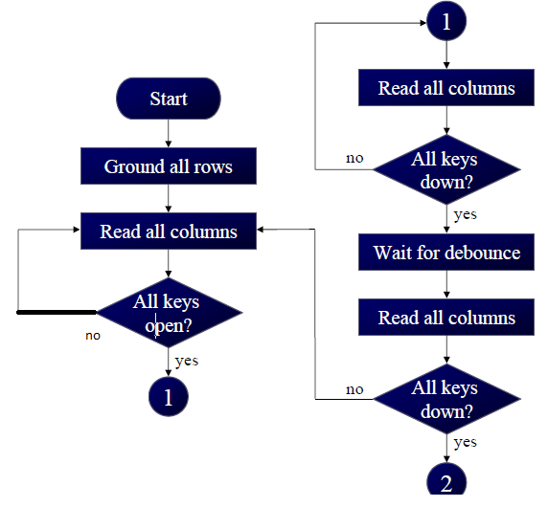
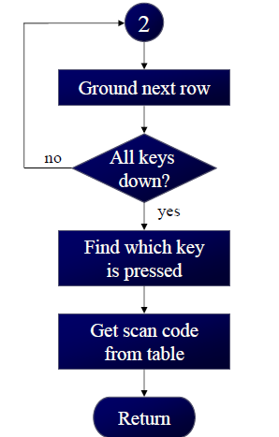
Flowchart: Scan the keyboard to detect and identify the key.

5.6: Interfacing 8051 to ADC
5. Explain how to interface an 8-bit ADC with 8051 Microcontroller.(April 2010, May 2008, Nov 2014)
ADCs (analog-to-digital converters) are widely used devices for data acquisition. A physical quantity (temperature, pressure, humidity, and velocity, etc.,) is converted to electrical (voltage, current) signals using a device called a transducer, or sensor.
- We need an analog-to-digital converter to translate the analog signals to digital numbers, so microcontroller can read them.
ADC804 IC is an analog-to-digital converter
- It works with +5 volts and has a resolution of 8 bits.
- Conversion time is defined as the time it takes the ADC to convert the analog input to a digital(binary) number.
- In ADC804 conversion time varies depending on the clocking signals applied to CLK R and CLK IN pins, but it cannot be faster than 110 μs.

CLK IN and CLK R
- CLK IN is an input pin connected to an external clock source
- To use the internal clock generator (also called self-clocking), CLK IN and CLK R pins are connected to a capacitor and a resistor, and the clock frequency is determined by
f = 1/1.1 RC
- Typical values are R = 10K ohms and C = 150 Pf. We get f = 606 kHz and the conversion time is 110 μs
D0-D7
- The digital data output pins
- These are tri-state buffered
- The converted data is accessed only when CS = 0 and RD is forced low
- To calculate the output voltage, use the following formula
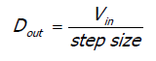
Dout = digital data output (in decimal),
Vin = analog voltage and step size (resolution) is the smallest change

Vref/2
- It is used for the reference voltage
- If this pin is open (not connected), the analog input voltage is in the range of 0 to 5 volts (the same as the Vcc pin)
- If the analog input range needs to be 0 to 4 volts, Vref/2 is connected to 2 volts.
Analog ground and digital ground
- Analog ground is connected to the ground of the analog Vin
- Digital ground is connected to the ground of the Vcc pin
- To isolate the analog V_{in} signal from transient voltages caused by digital switching of the output D0 – D7. This contributes to the accuracy of the digital data output.
The following steps must be followed for data conversion by the ADC804 chip
- Make CS = 0 and send a low-to-high pulse to pin WR to start conversion
- Keep monitoring the INTR pin
- If INTR is low, the conversion is finished
- If the INTR is high, keep polling until it goes low
- After the INTR has become low, we make CS = 0 and send a high-to-low pulse to the RD pin to get the data out of the ADC804.
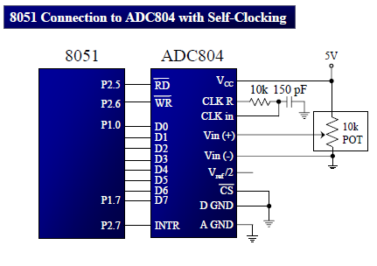

Examine the ADC804 connection to the 8051 in Figure. Write a program to monitor the INTR pin and bring an analog input into register A. Then call a hex-to ACSII conversion and data display subroutines. Do this continuously. (NOV 2007)
;p2.6=WR (start conversion needs to L-to-H pulse)
;p2.7 When low, end-of-conversion)
;p2.5=RD (a H-to-L will read the data from ADC chip)
;p1.0 – P1.7= D0 - D7 of the ADC804
MOV P1,#0FFH ;make P1 = input
BACK: CLR P2.6 ;WR = 0
SETB P2.6 ;WR = 1 L-to-H to start conversion
HERE: JB P2.7,HERE ;wait for end of conversion
CLR P2.5 ;conversion finished, enable RD
MOV A,P1 ;read the data
ACALL CONVERSION ;hex-to-ASCII conversion
ACALL DATA_DISPLAY ;display the data
SETB p2.5 ;make RD=1 for next round
SJMP BACK
5.7: DAC Interfacing with 8051

6. Explain the DAC interface with 8051. (May 2008)
Develop 8051 based system having 8Kbyte RAM to generate the triangular wave using DAC. (April 2017)
• Microcontroller is used in wide variety of applications like for measuring and control of physical quantity like temperature, pressure, speed, distance, etc.
• Microcontroller generates output which is in digital form.
- But the controlling system requires analog signal, so use DAC which converts digital data into equivalent analog voltage.
• In the figure shown, we use 8-bit DAC 0808. This IC converts digital data into equivalent analog Current.
- Hence we require an I to V converter to convert this current into equivalent voltage.

• According to theory of DAC Equivalent analog output is given as:
Ex:
- IF data =00H [00000000], Vref= 10v
Therefore, V0= 0 Volts.
- If data is 80H [10000000], Vref= 10VTherefore, V0= 5 Volts.

Different Analog output voltages for different Digital signals are given as:

Data | Output Voltage
00H | 0V
80H | 5V
FFH | 10V

Program to generate square wave:
Label | Mnemonics |  | Comments
 | Opcode | Operand
LOOP2 :  Delay:  LOOP3: | MOV  MOV  ACALL  MOV  MOV  ACALL  SJMP  MOV  DJNZ  RET | A,# 00  P1, AL  Delay  A,#FF  P1, AL  Delay  LOOP2  R_{O}, #F0  R_{O,} LOOP3 | ; Set Logic 0 level  ;Generate timing delay  ;Set logic 1 level  ; Generate timing delay  :Repeat to generates Square Wave  :Delay Program

Program to generate Triangular wave:

Label | Mnemonics |  | Comments
 | Opcode | Operand
LOOP3 :  LOOP1:  LOOP2: | MOV  MOV  MOV  INC  JNZ  MOV  MOV  MOV  DJNZ  SJMP | B,# 00  A, B  P1, A  B  LOOP1  B, #FF  A, B  P1, A  B, LOOP2  LOOP3 | ;Set logic 0  ;copy logic 0  ; Increment  ; If ZF=0, jump to next  Set logic 1  ;copy logic 1  ; Decrement &jump to next  ;Repeat

5.8: Temperature Sensors
7. Explain the interfacing of temperature sensor with 8051
- A thermistor responds to temperature change by changing resistance, but its response is not linear.
Temperature (C) | Tf (K ohms)
0 | 29.49
25 | 10
50 | 3.893
75 | 1.7
100 | 0.817

Signal conditioning is a widely used term in the world of data acquisition
- It is the conversion of the signals (voltage, current, charge, capacitance, and resistance) produced by transducers to voltage, which is sent to the input of an A to-D converter.
Signal conditioning can be a current-to voltage conversion or a signal amplification
- The thermistor changes resistance with temperature, while the change of resistance must be translated into voltage in order to be of any use to an ADC.
- The sensors of the LM34/LM35 series are precision integrated-circuit temperature sensors whose
output voltage is linearly proportional to the Fahrenheit/Celsius temperature.
- The LM34/LM35 requires no external calibration since it is inherently calibrated.
- It outputs 10 mV for each degree of Fahrenheit/Celsius temperature.
- The LM336 is used to overcome any power fluctuation in the power supply.
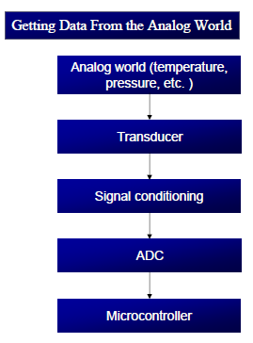

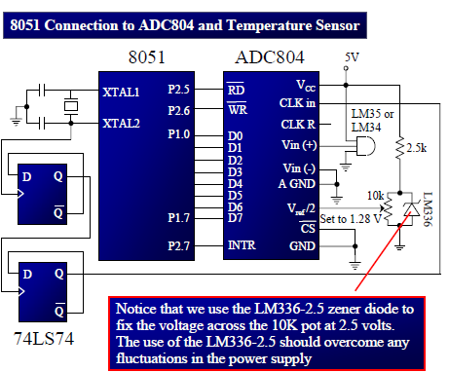

5.9: Interfacing to external memory

8. Describe the external memory and its interfacing with 8051. (NOV 2009, May 2008)
Write short notes on memory addressing. (Nov /Dec 2007)
How a program memory and a data memory are interfaced with 8051. (NOV 2007)

5.9.1: Connection to External Program ROM:
Explain how to interface ROM with the 8051. (NOV 2009)
We use RD to connect the 8051 to external ROM containing data.
For the ROM containing the program code, PSEN is used to fetch the code.
- 64K bytes are set aside for program code
- Program space is accessed using the program counter (PC) to locate and fetch instructions
- In some example we placed data in the code space and use the instruction MOVC A,@A+DPTR
to get data, where C stands for code

- The other 64K bytes are set aside for data.
- The data memory space is accessed using the DPTR register and an instruction called MOVX , where X stands for external – The data memory space must be implemented externally.

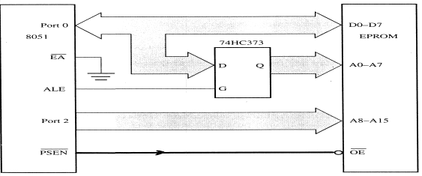

- In the 8031/51, port 0 and port 2 provide the 16-bit address to access external memory.
- P0 provides the lower 8 bit address A0 – A7, and P2 provides the upper 8 bit address A8 – A15
- P0 is also used to provide the 8-bit data bus D0 – D7.
- P0.0 – P0.7 are used for both the address and data paths using address/data multiplexing.
EA (External access)
- Connect the EA pin to Vcc to indicate that the program code is stored in the microcontroller’s
on-chip ROM .
- To indicate that the program code is stored in external ROM, this pin must be connected to GND.
ALE (address latch enable) pin is an output pin for 8051
- ALE = 0, P0 is used for data path.
- ALE = 1, P0 is used for address path.
- To extract the address from the P0 pins we connect P0 to a 74LS373 and use the ALE pin to
latch the address.
PSEN (program store enable) signal is an output signal for the 8051 microcontroller and must be connected to the OE pin of a ROM containing the program code.

5.9.2: Connection to External Data RAM
Interfacing external RAM with 8051
Write a brief note on external data move operations in 8051. (May 2016)
MOVX is a widely used instruction allowing access to external data memory space
- To bring externally stored data into the CPU, we use the instruction MOVX A,@DPTR
- To connect the 8051 to an external SRAM, we must use both RD (P3.7) and WR (P3.6)
- In writing data to external data RAM, we use the instruction MOVX @DPTR,A
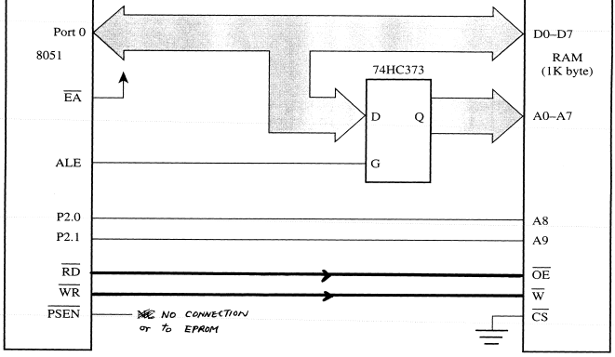

- In the 8031/51, port 0 and port 2 provide the 16-bit address to access external memory.
- P0 provides the lower 8 bit address A0 – A7, and P2 provides the upper 8 bit address A8 – A15
- P0 is also used to provide the 8-bit data bus D0 – D7.
- P0.0 – P0.7 are used for both the address and data paths using address/data multiplexing.
- Data space is accessed using the program counter (PC) to locate, read and write data.
ALE (address latch enable) pin is an output pin for 8051
- ALE = 0, P0 is used for data path.
- ALE = 1, P0 is used for address path.
- To extract the address from the P0 pins we connect P0 to a 74LS373 and use the ALE pin to
latch the address.
- EA & PSEN are not connected
*****************************************************************************

5.10: Interfacing stepper motor with 8051

9. Demonstrate the interfacing of the stepper motor with 8051 and explain its interfacing diagram and develop to rotate the motor in clock wise direction (April 2017, NOV 2016, May 2016, May 2010, May 2009, May 2008, May 2007, Nov 2015, 2014, 2013, 2011, 2010 & May 2013)
Describe in detail the microcontroller based system design with an example. (NOV 2102)

STEPPER MOTOR
- A stepper motor is a brushless, synchronous electric motor that converts digital pulses into mechanical shaft rotation.
- Every revolution of the stepper motor is divided into a discrete number of steps, and the motor must be sent a separate pulse for each step.
Applications:
Stepper motors can be used for position control in disk drive, dot matrix printers, robotics etc.
Construction:
- The stepper motor has four stator windings that are paired with a centre tapped common.
- This type of a stepper motor is commonly referred to as a four phase unipolar stepper motor.
- The center tap allows a change of current direction in each of two coils when a winding is grounded, there by resulting in a polarity change of the stator.
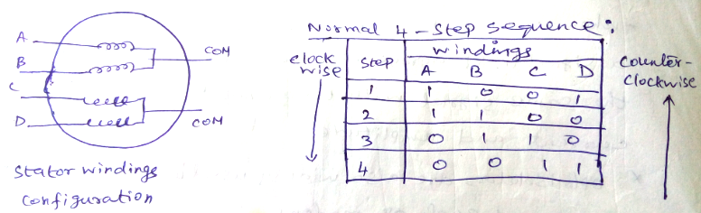
- It has total of 6 leads: 4 leads representing the four stator windings and 2 commons for the center tapped leads.
- The stepper motor shaft moves in a fixed repeatable increment, which allows one to move it to a accurate position.
- As the direction of the current is changed, the polarity is also changed causing the reverse motion of the rotor.
- As the sequence of power is applied to each stator winding, the rotor will rotate.

- We can start with any of the sequences, once started, and must continue in the proper order.
- Step angle of the stepper motor is defined as the minimum degree of rotation associated with a single step.
- To calculate step angle, simply divide 360 by number of steps a motor takes to complete one revolution.
- Motor rotating in full mode takes 4 steps to complete a revolution ,so step angle can be calculated as step angle ø = 360° / 4 =90.
- By knowing the stepper motor step angle helps to move the motor in correct angular position.
8051 Microcontroller connection to Stepper motor:
- The stepper motor is connected with Microcontroller output port pins through a ULN2003 driver.
- The Microcontroller’s pin can provide a maximum of 1-2mA current.
- Place a driver, such as the ULN 2003/ULN2803or a power transistor between the Microcontroller and the coil to energize the stator.
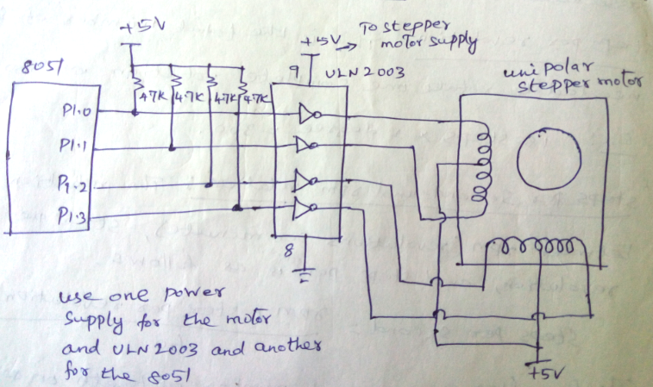
(Connection diagram between 8051 and Stepper motor)
- So when the microcontroller is giving pulses with particular frequency, the motor is rotated in clockwise or anticlockwise.
Program to interface Stepper motor with 8051:
The following steps show the 8051 connection to the stepper motor and its programming.
- The common wires are connected to the positive side of the motor’s power supply (+5V is sufficient).

- Four stator windings are controlled by four bits of the 8051 port (P1.0 to P1.3). Driver ULN2003 used to energize the stator.
Pin assignment with 8051:
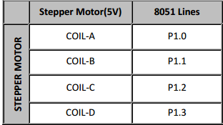
By giving the excitation as indicated above through port 1 we can rotate stepper motor in clockwise or anti clock wise direction.
Assembly Language Program:
To rotate motor in the clock wise direction (Forward direction):
MOV A,#66H ; Copy step value to Accumulator
BACK: MOV P1,A ; Copy step value from Accumulator to Port 1
RR A ; Rotate right to get consecutive step values
ACALL DELAY ; Call delay program
SJMP BACK ; repeat for next sequence.
DELAY: MOV R2,#F0
DELAY2: MOV R3,#FF
DELAY1: DJNZ R3,# DELAY1
DJNZ R2,# DELAY2
RET ; Return to main program

To rotate motor in the counter (Anti) clock wise direction (Reverse direction):
MOV A,#66H ; Copy step value to Accumulator
BACK: MOV P1,A ; Copy step value from Accumulator to Port 1
RL A ; Rotate left to get consecutive step values
ACALL DELAY ; Call delay program
SJMP BACK ; repeat for next sequence.
DELAY: MOV R2,#F0
DELAY2: MOV R3,#FF
DELAY1: DJNZ R3,# DELAY1
DJNZ R2,# DELAY2
RET ; Return to main program

To rotate motor in both forward and reverse direction:
MOV A,#66H ; Copy step value to Accumulator
FORWARD: MOV P1,A ; Copy step value from Accumulator to Port 1
RR A ; Rotate right to get consecutive step values
ACALL DELAY ; Call delay program
MOV R0,#04
DJNZ R0,FORWARD

REVERSE: MOV P1,A ; Copy step value from Accumulator to Port 1
RL A ; Rotate left to get consecutive step values
ACALL DELAY ; Call delay program
MOV R0,#04
DJNZ R0,REVERSE
SJMP FORWARD ; repeat for next sequence.

DELAY: MOV R2,#F0 :Delay program
DELAY2: MOV R3,#FF
DELAY1: DJNZ R3,# DELAY1
DJNZ R2,# DELAY2
RET ; Return to main program

The PIC microcontroller was developed by General Instruments in 1975. PIC was developed when Microelectronics Division of General Instruments was testing its 16-bit CPU CP1600.
Although the CP1600 was a good CPU but it had low I/O performance. The PIC controller was used to offload the I/O the tasks from CPU to improve the overall performance of the system.

In 1985, General Instruments converted their Microelectronics Division to Microchip Technology.
PIC stands for Peripheral Interface Controller. The General Instruments used the acronyms Programmable Interface Controller and Programmable Intelligent Computer for the initial PICs (PIC1640 and PIC1650).

In 1993, Microchip Technology launched the 8-bit PIC16C84 with EEPROM which could be programmed using serial programming method.
The improved version of PIC16C84 with flash memory (PIC18F84 and PIC18F84A) hit the market in 1998.
Development:
Since 1998, Microchip Technology continuously developed new high performance microcontrollers with new complex architecture and enhanced in-built peripherals. PIC microcontroller is based on Harvard architecture. At present PIC microcontrollers are widely used for industrial purpose due to its high performance ability at low power consumption. It is also very famous among hobbyists due to moderate cost and easy availability of its supporting software and hardware tools like compilers, simulators, debuggers etc. The 8-bit PIC microcontroller is divided into following four categories on the basis of internal architecture:

1. Base Line PIC
2. Mid-Range PIC
3. Enhanced Mid-Range PIC
4. PIC18

1. Base Line PIC
Base Line PICs are the least complex PIC microcontrollers. These microcontrollers work on 12-bit instruction architecture which means that the word size of instruction sets are of 12 bits for these controllers. These are smallest and cheapest PICs, available with 6 to 40 pin packaging. The small size and low cost of Base Line PIC replaced the traditional ICs like 555, logic gates etc. in industries.

2. Mid-Range PIC
Mid-Range PICs are based on 14-bit instruction architecture and are able to work up to 20 MHz speed. These controllers are available with 8 to 64 pin packaging. These microcontrollers are available with different peripherals like ADC, PWM, Op-Amps and different communication protocols like USART, SPI, I2C (TWI), etc. which make them widely usable microcontrollers not only for industry but for hobbyists as well.

3. Enhanced Mid-Range PIC
These controllers are enhanced version of Mid-Range core. This range of controllers provides additional performance, greater flash memory and high speed at very low power consumption. This range of PIC also includes multiple peripherals and supports protocols like USART, SPI, I2C and so on.

4. PIC18
PIC18 range is based on 16-bit instruction architecture incorporating advanced RISC architecture which makes it highest performer among the all 8-bit PIC families. The PIC18 range is integrated with new age communication protocols like USB, CAN, LIN, Ethernet (TCP/IP protocol) to communicate with local and/or internet based networks. This range also supports the connectivity of Human Interface Devices like touch panels etc.
MIPS stand for Millions of Instructions per Second

Besides 8-bit microcontrollers, Microchip also manufactures 16-bit and 32-bit microcontrollers. Recently Microchip developed XLP (Extreme Low Power) series microcontrollers which are based on NanoWatt technology. These controllers draw current in order of nanoamperes(nA).
PIC microcontrollers are also available with extended voltage ranges which reduce the frequency range. The operating voltage range of these PICs is 2.0-6.0 volts. The letter ‘L’ is included in controller’s name to denote extended voltage range controllers. For example, PIC16LFxxx (Operating voltage 2.0-6.0 volts).

The following section covers the PIC architecture in further detail. PIC18 series has been selected for the study because it is enhanced series of 8-bit PIC microcontroller. In this series, PIC18F4550 has been chosen to describe the architecture and other features due its moderate complexity.

Architecture:
PIC microcontrollers are based on advanced RISC architecture. RISC stands for Reduced Instruction Set Computing. In this architecture, the instruction set of hardware gets reduced which increases the execution rate (speed) of system.

PIC microcontrollers follow Harvard architecture for internal data transfer. In Harvard architecture there are two separate memories for program and data. These two memories are accessed through different buses for data communication between memories and CPU core. This architecture improves the speed of system over Von Neumann architecture in which program and data are fetched from the same memory using the same bus. PIC18 series controllers are based on 16-bit instruction set.

The question may arise that if PIC18 are called 8-bit microcontrollers, then what about them being based on 16-bit instructions set. ‘PIC18 is an 8-bit microcontroller’ this statement means that the CPU core can receive/transmit or process a maximum of 8-bit data at a time. On the other hand the statement ‘PIC18 microcontrollers are based on 16-bit instruction set’ means that the assembly instruction sets are of 16-bit.
The data memory is interfaced with 8-bit bus and program memory is interfaced with 16-bit bus as depicted in the following figure

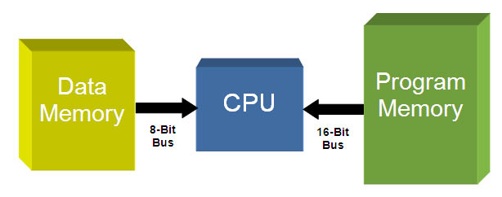

Fig. 4: Simple Block Diagram Of CPU Interfacing With Data And Program Memory In PIC

PIC18 Harvard Architecture
PIC microcontroller contains an 8-bit ALU (Arithmetic Logic Unit) and an 8-bit Working Register (Accumulator). There are different GPRs (General Purpose Registers) and SFRs (Special Function Registers) in a PIC microcontroller. The overall system performs 8-bit arithmetic and logic functions. These functions usually need one or two operands. One of the operands is stored in WREG (Accumulator) and the other one is stored in GPR/SFR. The two data is processed by ALU and stored in WREG or other registers.
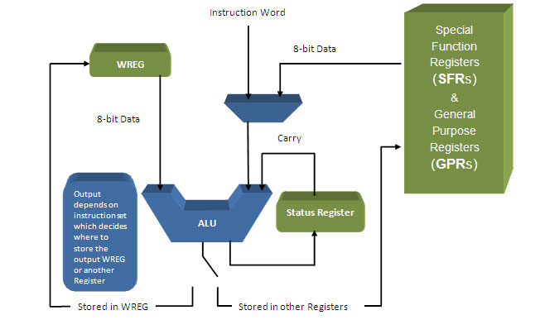

Fig. 5: Simple Block Diagram of Data Processing in PIC18 Harvard

The above process occurs in a single machine cycle. In PIC microcontroller, a single machine cycle consists of 4 oscillation periods. Thus an instruction needs 4 clock periods to be executed. This makes it faster than other 8051 microcontrollers.

Pipelining:
Early processors and controllers could fetch or execute a single instruction in a unit of time. The PIC microcontrollers are able to fetch and execute the instructions in the same unit of time thus increasing their instruction throughput. This technique is known as instruction pipelining where the processing of instructions is split into a number of independent steps.

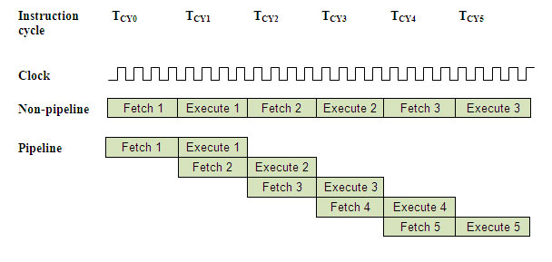
Fig. 6: Diagram Showing Instruction Pipelining Technique In PIC

Features and Peripherals
The PIC18F consists of the following features and peripherals.

Features:
· C Compiler Optimized Architecture with Optional Extended Instruction Set
· 100,000 Erase/Write Cycle Enhanced Flash
· Program Memory Typical
· 1,000,000 Erase/Write Cycle Data EEPROM Memory Typical
· Flexible oscillator option
Four Crystal modes, including High-Precision PLL for USB

o Two External Clock modes, Up to 48 MHz
o Internal Oscillator: 8 user-selectable frequencies, from 31 kHz to 8 MHz
o Dual Oscillator Options allow Microcontroller and USB module to Run at different Clock Speeds

Peripherals:
The PIC18F4550 microcontroller consists of following peripherals:

· I/O Ports: PIC18F4550 have 5 (PORTA, PORTB, PORTC, PORTD and PORTE) 8-bit input-output ports. PortB & PortD have 8 I/O pins each. Although other three ports are 8-bit ports but they do not have eight I/O pins. Although the 8-bit input and output are given to these ports, but the pins which do not exist, are masked internally.

Memory: PIC18F4550 consists of three different memory sections:
1. Flash Memory: Flash memory is used to store the program downloaded by a user on to the microcontroller. Flash memory is non-volatile, i.e., it retains the program even after the power is cut-off. PIC18F4550 has 32KB of Flash Memory.

2. EEPROM: This is also a nonvolatile memory which is used to store data like values of certain variables. PIC18F4550 has 256 Bytes of EEPROM.

3. SRAM: Static Random Access Memory is the volatile memory of the microcontroller, i.e., it loses its data as soon as the power is cut off. PIC18F4550 is equipped with 2 KB of internal SRAM.
· Oscillator: The PIC18F series has flexible clock options. An external clock of up to 48 MHz can be applied to this series. These controllers also consist of an internal oscillator which provides eight selectable frequency options varying from 31 KHz to 8 MHz.
· 8x8 Multiplier: The PIC18F4550 includes an 8 x 8 multiplier hardware. This hardware performs the multiplications in single machine cycle. This gives higher computational throughput and reduces operation cycle & code length.
· ADC Interface: PIC18F4550 is equipped with 13 ADC (Analog to Digital Converter) channels of 10-bits resolution. ADC reads the analog input, for example, a sensor input and converts it into digital value that can be understood by the microcontroller.

· Timers/Counters: PIC18F4550 has four timer/counters. There is one 8-bit timer and the remaining timers have option to select 8 or 16 bit mode. Timers are useful for generating precision actions, for example, creating precise time delays between two operations.

· Interrupts: PIC18F4550 consists of three external interrupts sources. There are 20 internal interrupts which are associated with different peripherals like USART, ADC, Timers, and so on.

· EUSART: Enhanced USART (Universal Synchronous and Asynchronous Serial Receiver and Transmitter) module is full-duplex asynchronous system. It can also be configured as half-duplex synchronous system. The Enhanced USART has the feature for automatic baud rate detection and calibration, automatic wake-up on Sync Break reception and 12-bit Break character transmit. These features make it ideally suited for use in Local Interconnect Network bus (LIN bus) systems.

· ICSP and ICD: PIC18F series controllers have In Circuit Serial Programming facility to program the Flash Memory which can be programmed without removing the IC from the circuit. ICD (In Circuit Debugger) allows for hardware debugging of the controller while it is in the application circuit.

· SPI: PIC18F supports 3-wire SPI communication between two devices on a common clock source. The data rate of SPI is more than that of USART.

· I2C: PIC18F supports Two Wire Interface (TWI) or I2C communication between two devices. It can work as both Master and Slave device.

ARM Processors

ARM, previously Advanced RISC Machine, originally Acorn RISC Machine, is a family of reduced instruction set computing (RISC) architectures for computer processors, configured for various environments. Arm Holdings develops the architecture and licenses it to other companies, who design their own products that implement one of those architectures‍—‌including systems-on-chips (SoC) and systems-on-modules (SoM) that incorporate memory, interfaces, radios, etc. It also designs cores that implement this instruction set and licenses these designs to a number of companies that incorporate those core designs into their own products.
Processors that have a RISC architecture typically require fewer transistors than those with a complex instruction set computing (CISC) architecture (such as the x86 processors found in most personal computers), which improves cost, power consumption, and heat dissipation. These characteristics are desirable for light, portable, battery-powered devices‍—‌including smartphones, laptops and tablet computers, and other embedded systems. For supercomputers, which consume large amounts of electricity, ARM could also be a power-efficient solution.
Arm Holdings periodically releases updates to the architecture. Architecture versions ARMv3 to ARMv7 support 32-bit address space (pre-ARMv3 chips, made before Arm Holdings was formed, as used in the Acorn Archimedes, had 26-bit address space) and 32-bit arithmetic; most architectures have 32-bit fixed-length instructions. The Thumb version supports a variable-length instruction set that provides both 32- and 16-bit instructions for improved code density. Some older cores can also provide hardware execution of Java bytecodes. Released in 2011, the ARMv8-A architecture added support for a 64-bit address space and 64-bit arithmetic with its new 32-bit fixed-length instruction set.
With over 100 billion ARM processors produced as of 2017, ARM is the most widely used instruction set architecture and the instruction set architecture produced in the largest quantity. Currently, the widely used Cortex cores, older "classic" cores, and specialized SecurCore cores variants are available for each of these to include or exclude optional capabilities.
The British computer manufacturer Acorn Computers first developed the Acorn RISC Machine architecture (ARM) in the 1980s to use in its personal computers. Its first ARM-based products were coprocessor modules for the BBC Micro series of computers. After the successful BBC Micro computer, Acorn Computers considered how to move on from the relatively simple MOS Technology 6502 processor to address business markets like the one that was soon dominated by the IBM PC, launched in 1981.

The Acorn Business Computer (ABC) plan required that a number of second processors be made to work with the BBC Micro platform, but processors such as the Motorola 68000 and National Semiconductor 32016 were considered unsuitable, and the 6502 was not powerful enough for a graphics-based user interface
According to Sophie Wilson, all the processors tested at that time performed about the same, with about a 4 Mbit/second bandwidth.
After testing all available processors and finding them lacking, Acorn decided it needed a new architecture. Inspired by papers from the Berkeley RISC project, Acorn considered designing its own processor. A visit to the Western Design Center in Phoenix, where the 6502 was being updated by what was effectively a single-person company, showed Acorn engineers Steve Furber and Sophie Wilson they did not need massive resources and state-of-the-art research and development facilities.
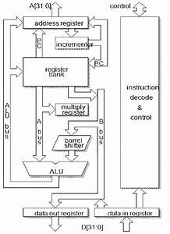
Wilson developed the instruction set, writing a simulation of the processor in BBC BASIC that ran on a BBC Micro with a 6502 second processor. This convinced Acorn engineers they were on the right track. Wilson approached Acorn's CEO, Hermann Hauser, and requested more resources. Hauser gave his approval and assembled a small team to implement Wilson's model in hardware

